**A MINI PROJECT REPORT ON**

**Indian Regional Language Translator**

SUBMITTED IN THE PARTIAL FULFILLMENT OF THE REQUIREMENTS OF UNIVERSITY OF MUMBAI FOR THE AWARD OF THE DEGREE

OF

# BACHELOR OF ENGINEERING

# IN

# COMPUTER ENGINEERING

**SUBMITTED BY**

### Jinal Gandhi(109)

### Yashvi Darji (115)

### Vedant Kudalkar (123)

### Kashyap Patel (131)

**UNDER THE GUIDANCE OF**

**Omkar Ghag**

# DEPARTMENT OF COMPUTER ENGINEERING

**VIDYA VIKAS TRUST’S**

**UNIVERSAL COLLEGE OF ENGINEERING**

**KAMAN ROAD, VASAI 401208**

**UNIVERSITY OF MUMBAI**

### 2023 -2024

## CERTIFICATE

This is to certify that the mini project report entitles

**“Indian regional Language Translator”**

Submitted by

### Jinal Gandhi(109)

### Yashvi Darji (115)

### Vedant Kudalkar (88)

### Kashyap Patel (131)

is a bonafide work has been carried out by them under the supervision of **Omkar Ghag** and it is approved for the partial fulfillment of the requirement of Savitribai Phule Pune University, for the award of the degree of **Bachelor of Engineering** (COMPUTER ENGINEERING).

**Omkar Ghag** **Jitendra Saturwar**

Guide Head Of Dept

Department of Computer Department of Computer

### (Dr. J. B. Patil) PRINCIPAL,

VIDYA VIKAS TRUST’S

UNIVERSAL COLLEGE OF ENGINEERING

KAMAN ROAD, VASAI 401208

## ACKNOWLEDGEMENT

I hereby take this opportunity to record my sincere thanks and heartily gratitude to **Omkar Ghag** for his useful guidance and making available to me his intimate knowledge and experience in making **“Indian regional Language Translator”** as a preparation of report in respect thereof. I am also thankful to my respective HOD **Jitendra Saturwar** of my Computer Engineering department. I express my special thanks and heartfelt gratitude to my respective staff members for inspiring me throughout the completion of this system.

The acknowledgement will be incomplete if I don’t record a sense of gratitude to my principal. I also express my sincere thanks to all those i.e. the management, lab assistants, my friends and family who have provided me valuable guidance towards the completion of this presentation as a part of the syllabus of the course.

I express my sincere gratitude towards the co-operative department who have provided me with valuable assistance and requirements for the presentation.

## CONTENTS

|  |  |  |
| --- | --- | --- |
| **Sr. No** | **Title of Chapter** | **Page no.** |
| 1. | Abstract | 5 |
| 2. | Introduction | 6 |
| 3. | Software Requirements Specification | 7 |
| 4. | System Architecture | 10 |
| 5. | Conclusion | 11 |
| 6. | References | 12 |

1. **ABSTRACT**

The Indian Regional Language Translator project aims to bridge linguistic divides and promote inclusive communication in the diverse linguistic landscape of India. India boasts a rich tapestry of languages and dialects, with each region having its unique linguistic heritage. However, this diversity often leads to communication barriers, hindering information exchange and social cohesion.

This project addresses the need for an efficient and user-friendly solution to translate text and speech across various Indian languages. The primary goal is to develop a robust, scalable, and accessible language translation system that can facilitate seamless communication among individuals, businesses, and government services throughout the country.

The Indian Regional Language Translator project is a transformative initiative designed to address the linguistic diversity in India, where hundreds of languages and dialects coexist. This linguistic mosaic can be both a source of cultural richness and a significant communication challenge. The project's primary aim is to develop a comprehensive language translation system that bridges these linguistic gaps, facilitating communication among individuals, businesses, and government services. Leveraging cutting-edge Natural Language Processing (NLP) and Machine Learning (ML) technologies, this project seeks to create a versatile and accessible translation tool. It encompasses an extensive language database, language-specific NLP models, user-friendly interfaces, real-time translation capabilities, and a commitment to inclusivity. By breaking down language barriers, this project aspires to empower users and contribute to the preservation of India's cultural diversity, fostering a more connected and harmonious nation.

1. **INTRODUCTION**

The Indian Regional Language Translator project represents a seminal undertaking in the domain of Natural Language Processing (NLP) and Machine Learning (ML) technologies. India's linguistic diversity, characterized by a plethora of languages and dialects, presents a complex challenge in terms of facilitating cross-linguistic communication. In response, this project seeks to construct an advanced and adaptive language translation system that harnesses the power of NLP algorithms and deep learning models.

This initiative rests upon the foundation of an extensive language database, meticulously curated to encompass the nuances of Indian languages and dialects. The NLP models, intricately designed to capture the idiosyncrasies of each language, will enable highly accurate translation of text and speech.

In addition to static translations, this project aspires to deliver real-time translation capabilities, allowing for instantaneous, context-aware interpretation of spoken language. Furthermore, an inclusive approach is at the core of this project, ensuring accessibility for users with varying levels of digital literacy, including those residing in remote and rural areas. Collaboration with linguistic experts and native speakers from diverse communities will be pivotal for fine-tuning the NLP models, thereby preserving linguistic accuracy and cultural nuances.

As the project evolves, it will establish a feedback loop, enabling users to report errors and contribute to ongoing improvements in translation accuracy and language coverage. In summary, the Indian Regional Language Translator project merges NLP and ML technologies to transcend linguistic barriers, empowering individuals, businesses, and government services in fostering cross-cultural communication, and preserving India's rich linguistic heritage in the digital age.

1. **SOFTWARE REQUIREMENTS SPECIFICATION**

3.1. Introduction

3.1.1 Purpose

The purpose of the Indian Regional Language Translator project is to break down language barriers in India, fostering inclusive communication, preserving linguistic and cultural diversity, empowering businesses and individuals, enhancing access to government services, promoting cross-cultural exchange, and improving education. It seeks to bridge linguistic divides, contribute to economic growth, and ensure digital inclusion while continuously improving its translation capabilities to adapt to the dynamic linguistic landscape of India.

3.1.2 Scope

The scope of an Indian language translator is to translate text from one Indian regional language to another, or between an Indian regional language and English. The translator should be able to handle a wide range of text types, including news articles, government documents, educational materials, and literary works. The translator should also be able to translate code-mixed text and idiomatic expressions.

3.2. System Overview

A system overview for an Indian Regional Language Translator would encompass the technology, architecture, and components involved in creating a system capable of translating between Indian regional languages. Such a system would be a valuable tool for breaking down language barriers and promoting communication and understanding among the diverse linguistic communities in India.

3.2.1 System Description

This system serves as a powerful tool for promoting linguistic diversity and inclusivity in a nation with a myriad of languages and dialects. By facilitating communication across languages, it contributes to social cohesion, economic development, and cultural exchange in a country as linguistically rich as India.

3.2.2 Functional Requirements

Developing a language translation system for Indian regional languages using NLP in Python requires several functional requirements. Here's an outline of key functionalities:

Language Detection: Implement a language detection module to identify the source language of the input text or speech, crucial for accurate translation.

Language Translation Models: Develop language-specific NLP models for various Indian regional languages, ensuring they capture linguistic nuances and context.

Text Translation: Implement text translation functions that accept input in one language and produce an equivalent translation in the desired regional language.

Accessibility Features: Ensure the application is accessible to users with varying degrees of digital literacy and disabilities.

Customization Options: Provide users with options to customize and fine-tune translations, such as selecting formal or informal language styles.

These functional requirements provide a foundation for creating a comprehensive Indian regional language translation system using NLP in Python. The project should continuously evolve to address the dynamic linguistic landscape and user needs.

3.2.2 Non-Functional Requirements

Performance: The system can use a cache to store frequently accessed translations. This can improve the response time of the system, especially for popular phrases and sentences.

Scalability: The system can be designed to scale horizontally using a cloud-based infrastructure. This will allow the system to add more servers and resources as needed to handle increasing demand.

Accuracy: The NLU module can be trained on a large and diverse dataset of Indian language text and code.

1. **System Architecture**

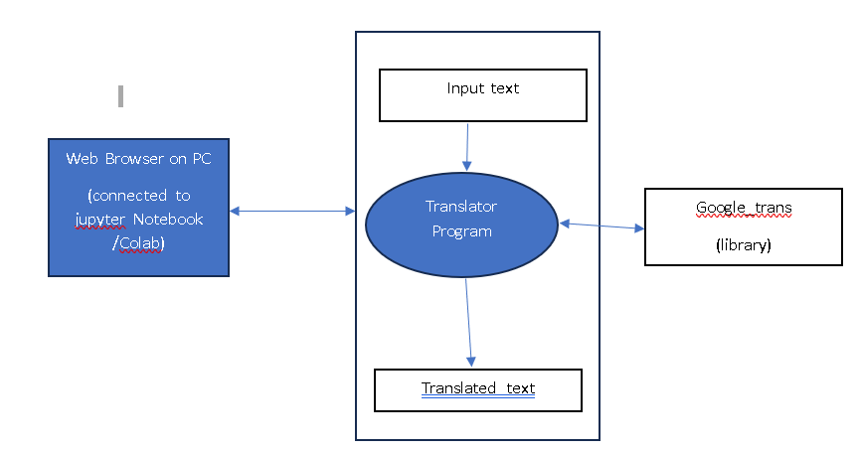

User: The user will interact with the translator want to communicate in this indian region

Input text:Accordingly text will be user will put the input in which regional language user want to communicate.

Translator Program: Based on the text understanding the response will be given to the user

google_trans: This google translator library that allow to translator program use it.

Translated text::Accordingly text will be user will put the input the chosen regional language will be translated

**Implementation**

**Code:**

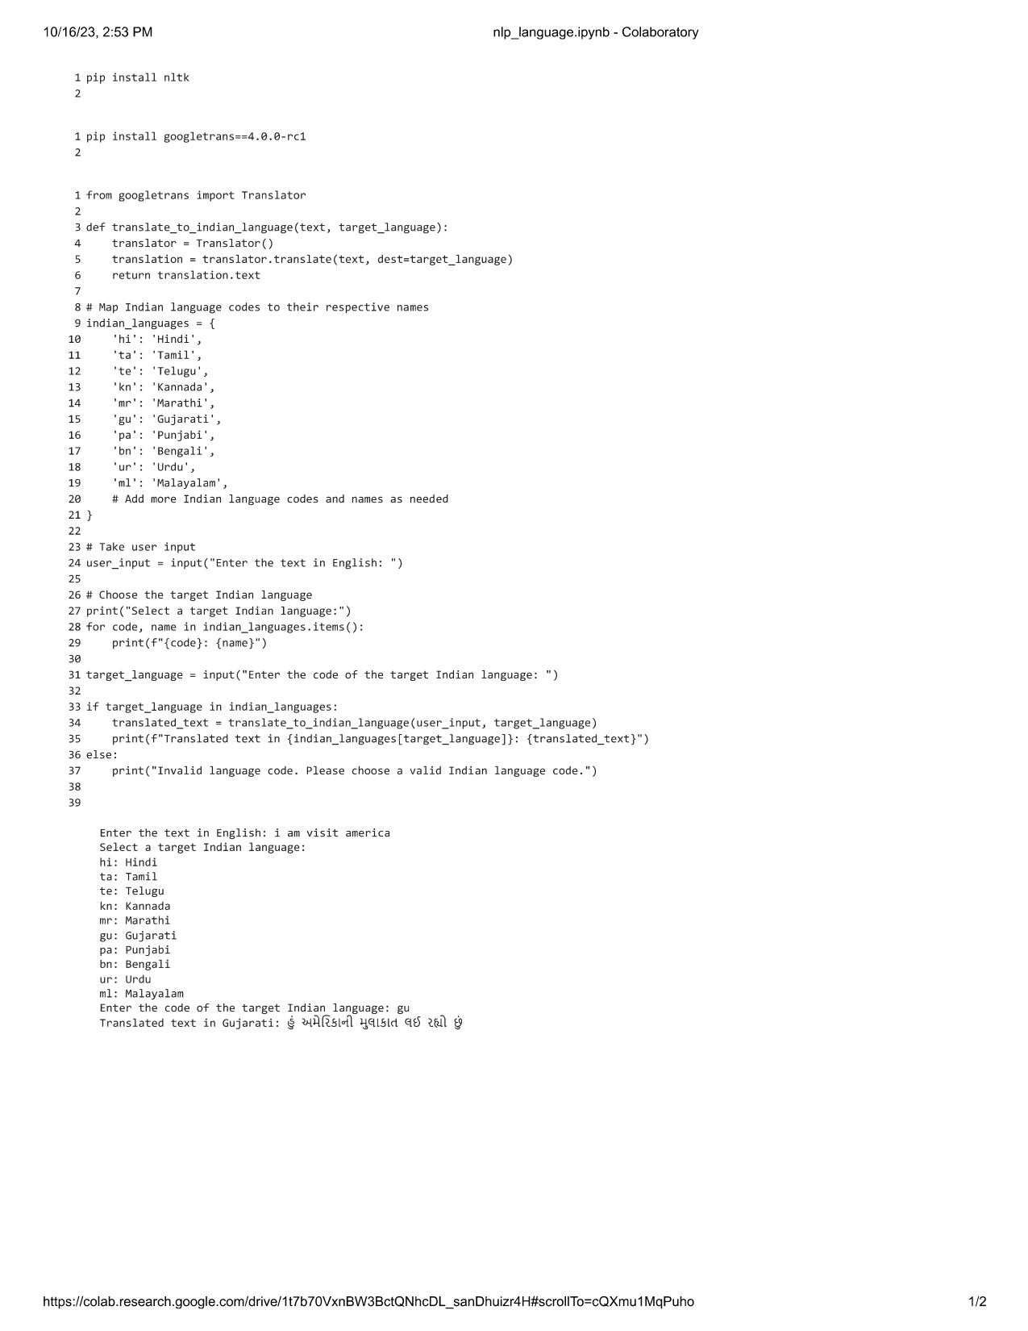

**Output:**



**Conclusion**

The Indian Regional Language Translation system is a significant undertaking with the potential to make a major impact on India. The system is designed to be comprehensive, user-friendly, and scalable. The IRLT system has the potential to break down language barriers, empower businesses and individuals, enhance access to government services, and improve education.

1. **References**

* <https://www.languageservicesbureau.com/indian-languages-translation.php>

[/](https://www.geeksforgeeks.org/nlp-project-ideas-for-beginners/)

* <https://towardsdatascience.com/nlp-for-indian-languages-310d1d8a10b6>
* <https://www.analyticsvidhya.com/blog/2021/10/complete-guide-to-build-your-ai-chatbot-with-nlp-in-python/>
* <https://www.geeksforgeeks.org/inltk-natural-language-toolkit-for-indic-languages-in-python/>
* <https://medium.com/analytics-vidhya/popular-python-libraries-in-nlp-dealing-with-language-detection-translation-beyond-7b8e7cb2928e>